Chapter 3, Problem 16.

Determine voltages v₁ through v₃ in the circuit of Fig. 3.65 using nodal analysis.
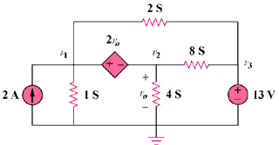

Figure 3.65
For Prob. 3.16.

